**WORKSHEET - 3**

**Q: - Sort Colors**

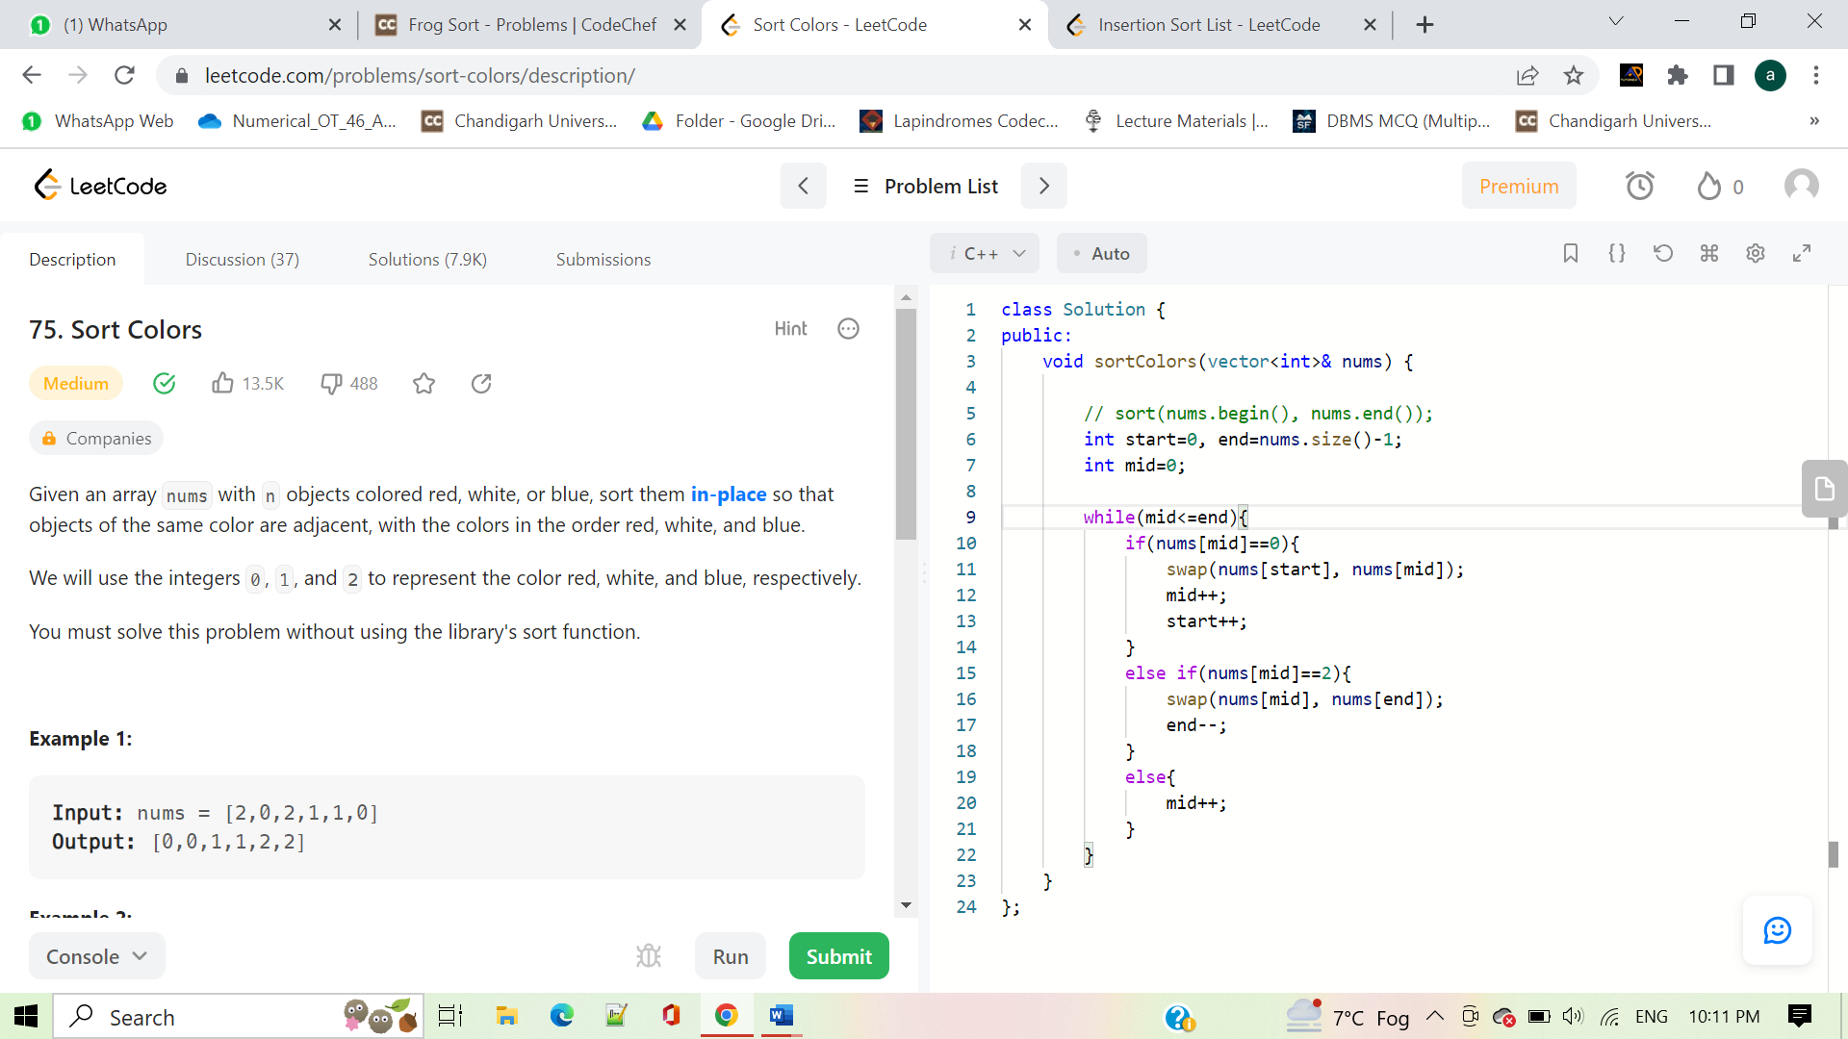

**Q: - candies**

#include <iostream>

#include<bits/stdc++.h>

using namespace std;

int main() {

// your code goes here

int t;

cin>>t;

while(t--){

int n;

cin>>n;

int arr[n];

for(int i=0;i<n;i++){

cin>>arr[i];

}

sort(arr, arr+n);

int minimum = arr[0];

int maximum = arr[n-1];

int diff = maximum-minimum;

bool flag=false;

for(int i=0;i<n;i++){

if(arr[i]==diff){

flag=true;

}

}

if(flag) cout<<diff<<endl;

else cout<<"NO"<<endl;

}

return 0;

}

**Q : - Chef and Patients**

#include <bits/stdc++.h>

using namespace std;

int main() {

int t; cin >> t;

while(t--){

int n ;

cin >> n;

vector<pair<int, int>> arr(n);

int maximum = 0;

for(int i=0; i<n; i++) {

cin >> arr[i].first;

arr[i].second = i;

maximum = max(maximum, arr[i].first);

}

// 0 1 2 3 4

// 3 2 0 2 1

for(int i=0; i<n; i++) {

arr[i].first = maximum - arr[i].first;

}

// 0 1 2 2 3

// 2 4 1 3 0

sort(arr.begin(), arr.end());

vector<int> ans(n);

for(int i=0; i<n; i++){

ans[arr[i].second] = i+1;

}

for(int i=0; i<n;i++){

cout <<ans[i]<< " ";

}

cout<<endl;

}

return 0;

}

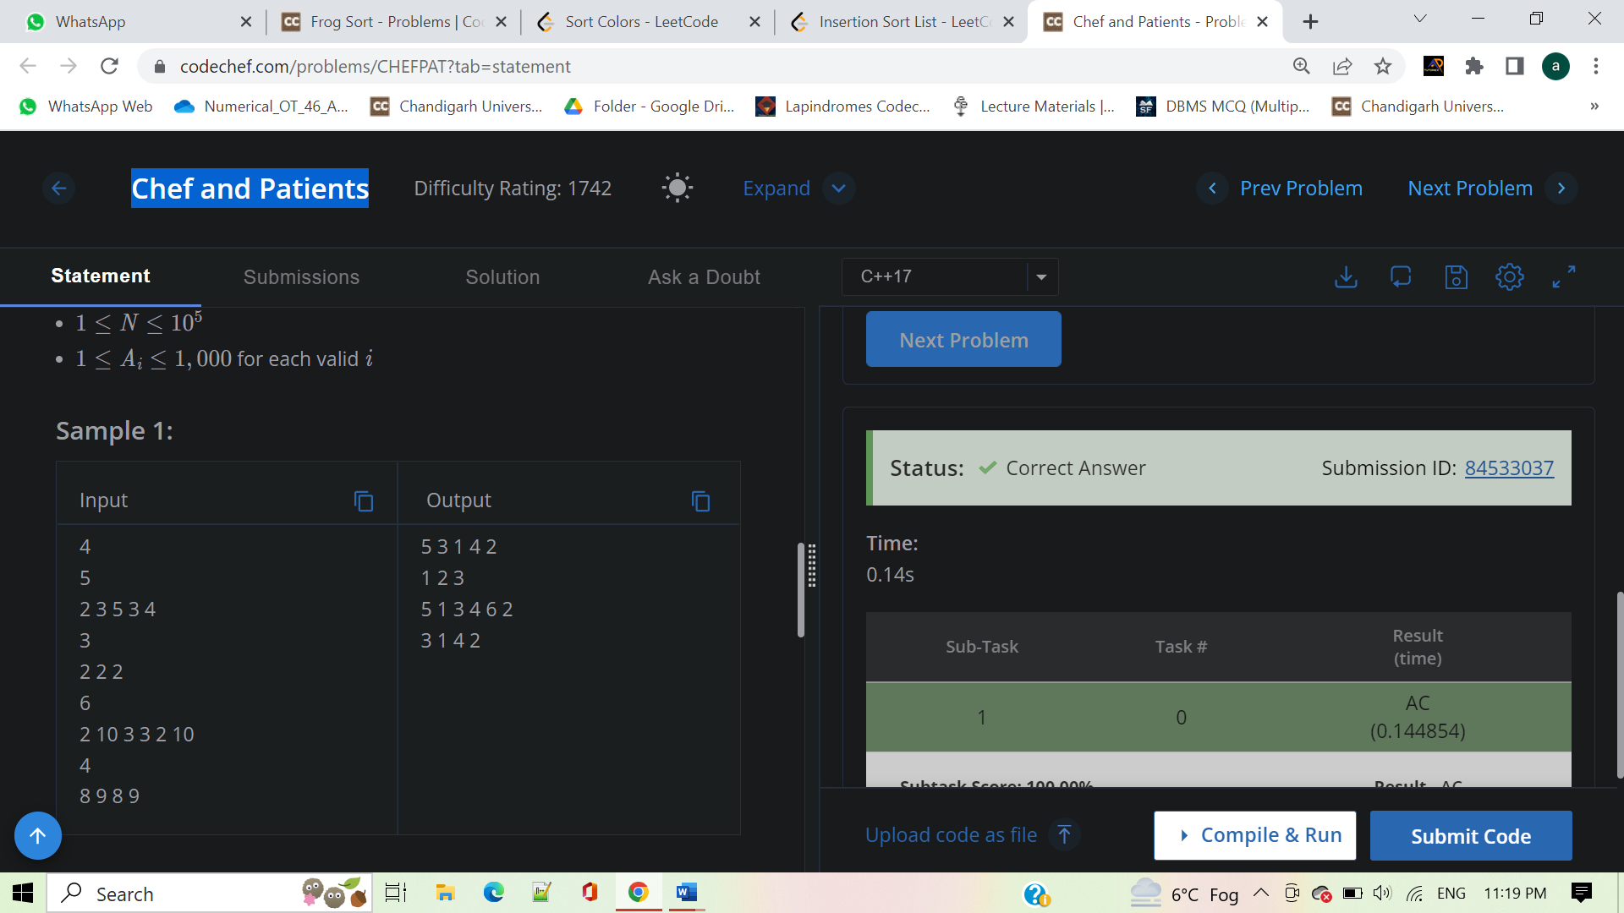

**451. Sort Characters By Frequency**

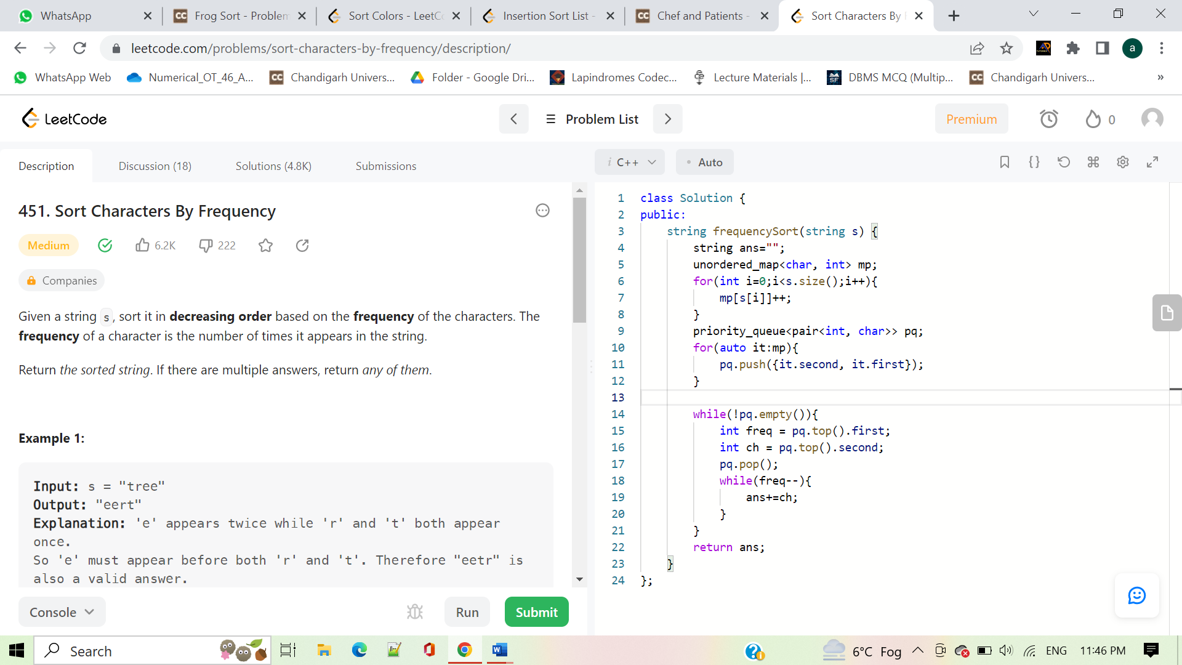

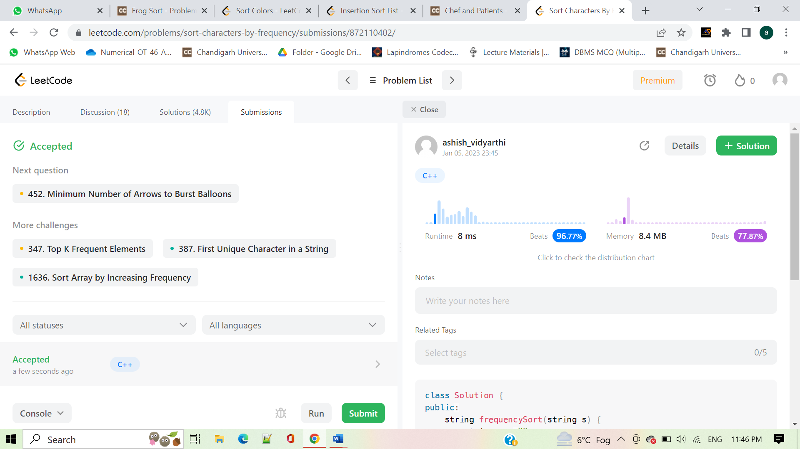

**Q - Chef and Lockout Draws**

#include <iostream>

using namespace std;

int main() {

int t;

cin>>t;

while(t--){

int a,b,c;

cin>>a>>b>>c;

if(a+b==c||b+c==a||c+a==b)

cout<<"YES"<<endl;

else

cout<<"NO"<<endl;

}

return 0;

}

**912. Sort an Array**

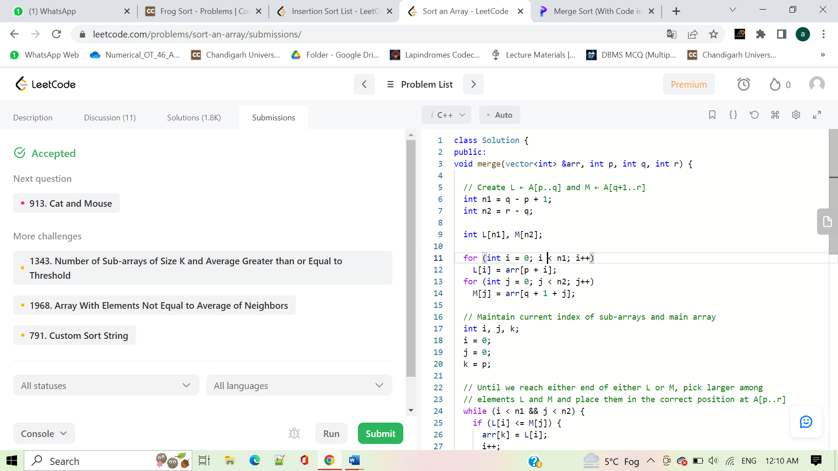

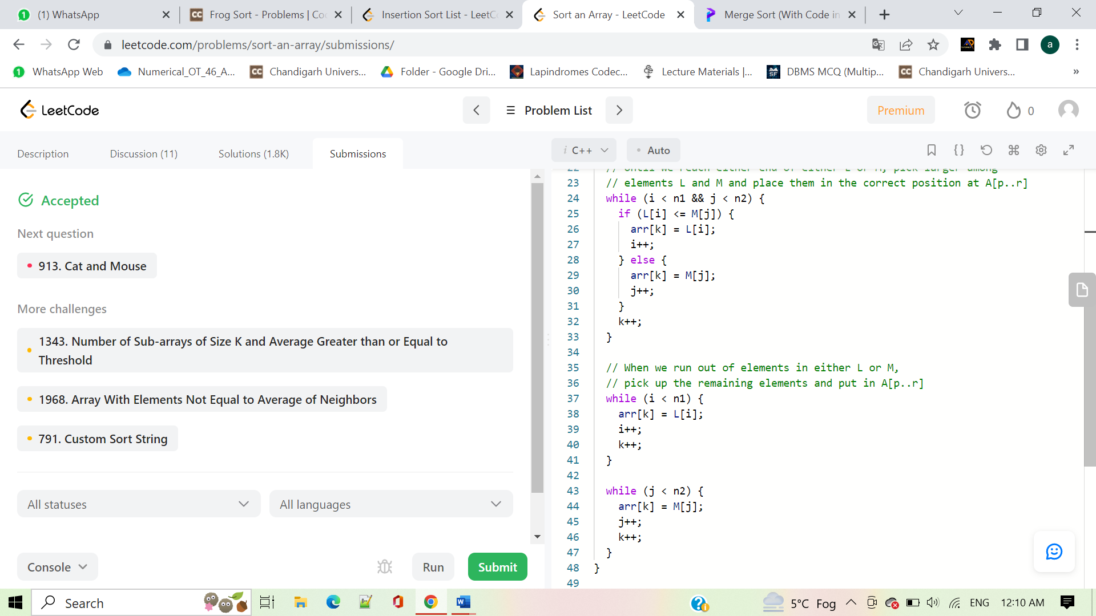

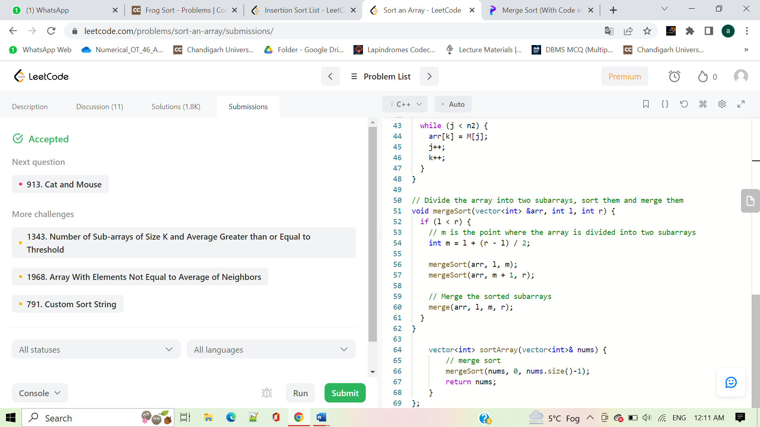

**164. Maximum Gap**

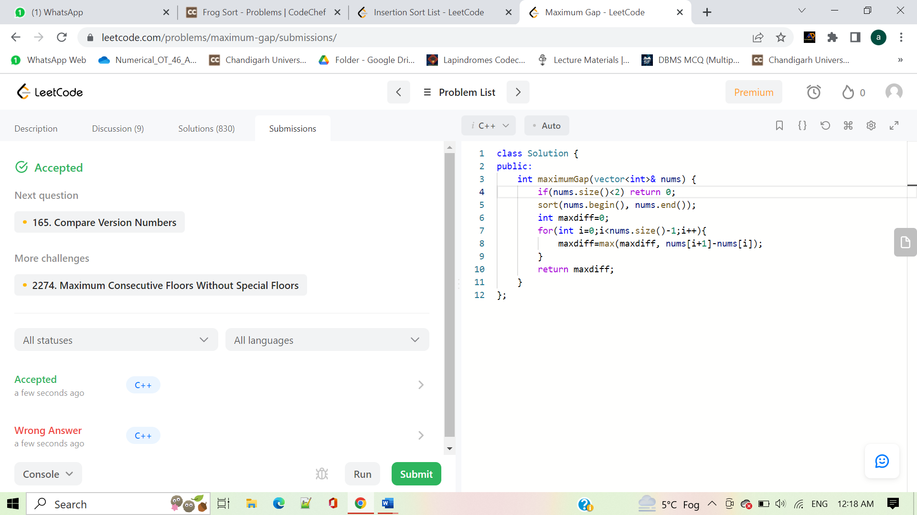

**581. Shortest Unsorted Continuous Subarray**

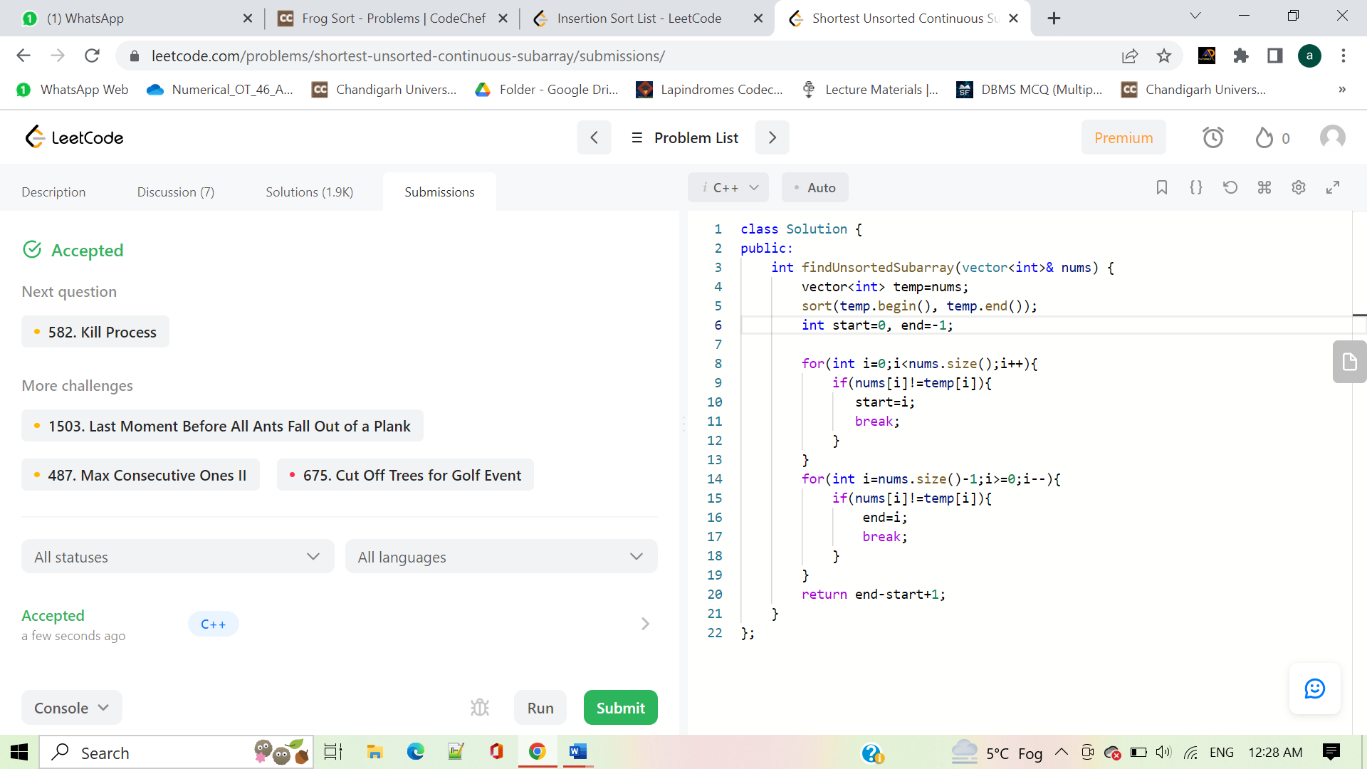

**767. Reorganize String**

